**Report: Data Integration and Cleaning Report for Food Flow Data**

This report outlines the process of merging and cleaning food flow data collected by VIAMO and OAF reports. The process aims to enhance data quality and consistency across the datasets, ensuring insights can be drawn accurately from the data.

**Data Cleaning Process:**

1. **Merging Datasets**:
   * Combined three OAF datasets using date and time as unique identifiers (UIDs).
2. **Duplicate Removal**:
   * Removed duplicate entries within the dismark dataset to maintain data integrity.
3. **Data Standardization**:
   * Matched columns from OAF data with VIAMO datasets to standardize information across datasets.
4. **Combining datasets**:
   * Combine cleaned data from OAF AND Viamo to get final for all rounds.
   * Column Selection: Relevant columns were chosen for analysis, including date, time, Province, District, items sold label, food item- English, source channel, source location, and market transport.
5. **Detailed Cleaning Process**:
   * **Source Location**: Created a new column, "Source Location," incorporating data from three columns on the source of food items:
     + **District**: Matched with responses in the "District Item Is Sold From" column.
     + **Other District**: Aligned with responses in the "District_MM_source food other" column.
     + **International**: Matched with responses in the "Which country did you source the food item?" column.
     + **Don’t Know**: Retained as is.
   * Excluded responses from VIAMO data indicating "Rwanda" except when "neighbor fam" was mentioned as the source.
6. **Question Consistency**:
   * Matched transportation-related questions between OAF and VIAMO datasets for consistency in data collection.
   * Ensured future data collection aligns with the same transportation question in both VIAMO and OAF reports.
7. **Visulazitions:**

* **Frequency of market transport modes**

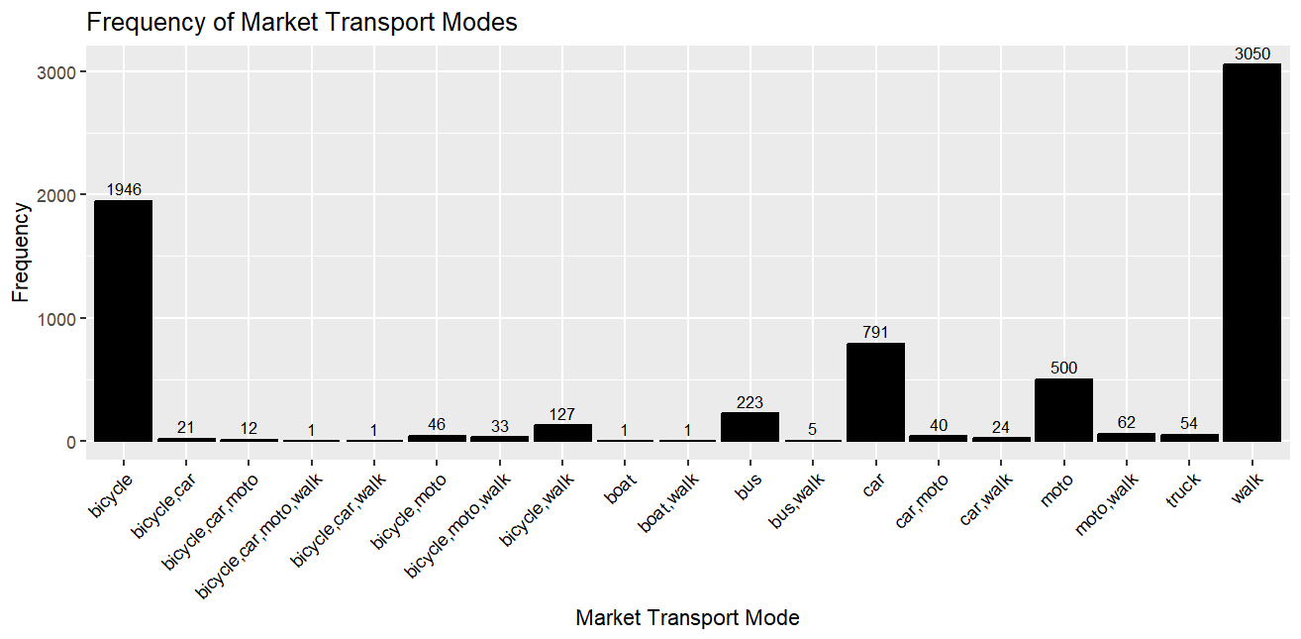

* **Source channel distribution**

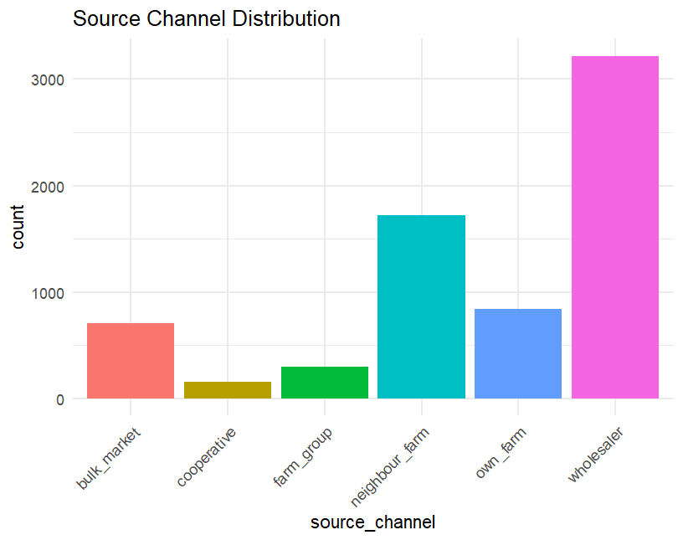

* **Flows of different food items in Rwanda districts for all rounds**

Ex: cabbage

